System Requirements Statement (SRS) –

Doctor’s Appointment

1. Introduction 3

2. Functional Requirements 4

2.1 Admin Module 5

2.2 Doctor Module 7

2.3 Patient Module 11

2.4 Use Case Diagram.............................................................................................................................13

# Introduction

This document explains the system requirements and scope for developing Doctor’s Appointment System.

Doctor’s Appointment System could be divided into three main parts - Admin part, Doctor part and Patient part.

# Functional Requirements

The Account part of Doctor’s Appointment System has three modules which are divided into 13 processes described as below.

|  |  |  |
| --- | --- | --- |
| **No** | **BRS requirement ID** | **Description** |
| **2.1 Admin Module** | | |
| **2.1.1** | **F2** | **Login** |
| **2.1.2** | **F3** | **Update Profile** |
| **2.1.3** | **F4** | **Forgot Password** |
| **2.1.4** | **F5** | **Remove Doctor** |
| **2.1.5** | **F6** | **View Doctor Details** |
| **2.1.6** | **F7** | **View Patient Details** |
| **2.1.7** | **F8** | **View Appointment** |
| **2.1.8** | **F9** | **View Schedule** |
| **2.1.9** | **F10** | **Approve Doctor** |
| **2.1.10** | **F11** | **Statistics** |
| **2.1.11** | **F12** | **Logout** |
| **2.2 Doctor Module** | | |  |
| **2.2.1** | **F13** | **Register** |
| **2.2.2** | **F14** | **Login** |
| **2.2.3** | **F15** | **Update Profile** |
| **2.2.4** | **F16** | **Forgot Password** |
| **2.2.5** | **F17** | **Change Password** |
| **2.2.6** | **F18** | **Add Schedule** |
| **2.2.7** | **F19** | **View Appointment** |
| **2.2.8** | **F21** | **Cancel Appointments** |
| **2.2.9** | **F22** | **Make Payment** |
| **2.2.10** | **F23** | **Payment Status** |
| **2.2.11** | **F24** | **Logout** |
| **2.3 Patient Module** | | |
| **2.3.1** | **F18** | **Register** |
| **2.3.2** | **F19** | **Login** |
| **2.3.3** | **F20** | **Update Profile** |
| **2.3.4** | **F21** | **Forgot Password** |
| **2.3.5** | **F22** | **Change Password** |
| **2.3.6** | **F23** | **View Schedule** |
| **2.3.7** | **F24** | **Search Doctor** |
| **2.3.8** | **F25** | **Book Appointment** |
| **2.3.9** | **F26** | **Cancel Appointment** |
| **2.3.10** | **F27** | **View Appointment** |
| **2.3.11** | **F28** | **Logout** |
|  |  |  |

2.1 Admin Module

### Login Process

* Admin is the main authority and will have access to all the details of doctors and patients.
* The User Id and Password should be checked in the following ways:
* First, The User Id and Password should exist in the database and the pair should be matched correctly.
* If The User Id and the Password are not valid, the authentication cannot be provided.
* Second , The role linked to this User Id should be “admin”.
* When the role is “admin”, then he will be redirected to the Admins Home Page.
* After the above two checks are verified then only the admin is directed to his respective page.

### Forgot Password Process

* A Admin may forget his password , therefore a recovery method should be provided by the system.

The recovery method for password is as follows:

* The Admin will have to enter his/her User Id and then click on forgot password link.
* Next the admin will have to enter his/her registered Email Id.
* If this pair of User Id and Email Id exists and matches correctly then the password will be sent on email address of admin, else invalid email address message will be displayed.
* Thus, the admin can retrieve his password from email and login into the system successfully.

### Register New Doctor

* Admin will have authority to register newly recruited doctor and walk-in patients.
* For this admin will approve an account of that newly recruited doctor after verification.
* Following are the fields for registration of new doctor:
* Name
* Qualification
* Specialty
* Experience
* Gender
* Email
* Address
* Contact Number

### Remove Doctor/Patient

* Admin will have authority to remove doctor.
* Admin will also have authority to remove patient whose account is not invalid.

### View Doctor Details

* Admin can view all the details of doctors along with their schedule.
* Admin will also view all appointments booked under specific doctor and their status.

### View Patient Details

* Admin can view all the details of patient and appointment history.
* Admin will also view all prescriptions of patient provided by specific doctor of that patient.

### Logout

* Admin can logout his/her account.
* The System will move to Home Page.

## Doctor Module

### 2.2.1 Login Process

* Doctor can login into the system using his User Id and Password that has been approved by the Admin after the recruitment of the Doctor.
* The User Id and Password should be checked in the following ways:
* First, The User Id and Password should exist in the database and the pair should match correctly with one specific doctor.
* If The User Id and the Password are not equal to what the doctor has registered, the authentication cannot be provided.
* Second, the role linked to this User Id should be “doctor”.
* When the role is “doctor”, then he redirected to the Doctor’s Home Page.
* The Doctor account is valid until he/she is registered with the clinic and authorized by the admin.
* After the above two checks are verified then only the Doctor is directed to his respective page.

### 2.2.2 Forgot Password Process

* A Doctor may forget his password, therefore a recovery method should be provided by the system.

The recovery method for password is as follows:

* The Doctor will have to enter his/her User Id and then click on forgot password link.
* Next the doctor will have to enter his/her registered Email Id.
* If this pair of User Id and Email Id exists and matches correctly then the password will be sent on email address of that doctor, else invalid email address message will be displayed.
* Thus, the doctor can retrieve his password from email and login into the system successfully.

### 2.2.3 Change Password Process

* Doctor once logged in successfully and directed to his respective page will have an option to change his password.

Following must be done to change the password:

* Doctor will have to enter the old/current password.
* Then he/she will have to enter the new password twice to avoid typing error.
* The entered new password will be validated as per the following rules:
* No of characters – 8 to 16
* It must include at least one numeric figure, a capital alphabet, a small alphabet and a special character.

If the newly entered password is not as per the above rules the user will be prompted with incorrect format error and re-enter message.

* After the new password is entered as per rules and only when the current password is correct, Doctor could change their Password.
* When the current password is changed into new password, System will compel the doctor to login again.

### 2.2.4 Update Profile

* Once the doctor registration done by admin. Doctor can login his/her account and will update his/her profile.
* Following are the fields for registration of new doctor:
* Name
* Experience
* Email
* Address
* Contact Number

### 2.2.5 Add Schedule Process

* A Doctor should add his availability schedule for consultation well in advance so that a patient can book an appointment.
* It will be mandatory for a doctor to provide his availability schedule at least for an upcoming week in advance.

Following will be the fields available to doctor for adding his schedule:

1. Date for which schedule is to be set.
2. Individual patient slot or larger slots with patient limit.
3. Time for each slot/checkup.
4. Buffer time between two checkups.
5. Break time.

#### 2.2.6 View Appointments

* The Home page of doctor’s login will show all the appointments that are booked for him.
* Here the doctor can view all the appointments in the order of consultation date and time.

Following will be the details about appointment displayed in this feature:

* Date and time of Appointment
* Name of the Patient

#### 2.2.7 View Patient Information

* Along with whose appointments are scheduled for a doctor he can also view the basic information of the patient required for checkup.
* This information will include following details:
* Patient name

### 2.2 .8 Cancel Appointment

* Doctors can cancel appointment
* A cancel option is placed beside each appointment in the list and when it is clicked particular appointment is deleted.

**2.2.9 Payment**

* Doctors can take monthly or yearly Subscriptions

**2.2.10 Logout**

* Doctor can logout his/her account.
* The System will move to Home Page.

## Patient Module

### 2.3.1 Registration Process

* In the case of registration, the user has to provide following personal information:
  + Name
  + Password
  + Verify password
  + Gender
  + Age
  + Mobile No
  + Email address
  + Address

all these information is entered into their respective fields in a form.

* The system checks if the email is already registered if all these are correct, then the new user is created by inserting all these information in the database else an error message is displayed.

### 2.3.2 Login Process

* Doctors Appointment System always compels user authentication before using itself except when a new account is successfully created.
* The user authentication demands User Id and Password. The User Id and the Password should be checked in three ways.
  + First, The User Id and the Password should be existed and correct.
* If The User Id and the Password are not equal to what the patient has registered, the authentication cannot be provided.
  + Second, the User Type linked to the User Id should be "Patient".
* When the User Type is "Patient", user can be placed on “Patient Home Page”.
* The Patient account is valid until he/she is registered with the clinic and authorized by the admin.
* After the above two checks are verified then only the Patient is directed to his respective page.

### 2.3.3 Forgot Password Process

* A Patient may forget his password, therefore a recovery method should be provided by the system.

The recovery method for password is as follows:

* The Patient will have to enter his/her User Id and then click on forgot password link.
* Next the patient will have to enter his/her registered Email Id.
* If this User Id exists and matches correctly then the password will be sent on email address of that patient, else invalid email address message will be displayed.
* Thus, the patient can retrieve his password from email and login into the system successfully.

### 2.3.4 Update Account Process

* Doctor’s Appointment System should provide the function which makes the account updated for patient.
* The Patient could update his/her personal details as described below.
* First Name
* Last Name
* User Name
* Email Address
* Mobile No
* Gender
* Age
  + All items are compulsory demanded, but updating is optional.

### 2.3.5 Book Appointment

* Appointment can only book if the user is logged in else the user is redirected to the log in page after which the user is redirected back to the previous action page.
* Patient can see available schedule of doctors.
* As per available schedule he/she can book an appointment.
* Once he/she will book an appointment, he/she will get confirmation mail.

### 2.3.6 Cancel Appointment

* Patient can cancel his/her appointment before 24 hrs.
* A cancel option is placed beside each appointment in the list and when it is clicked particular appointment is deleted.

### 2.3.7 View Appointment

* Patient can see list of all his/her current and previous appointments.
* The Home page of patient login will show all the appointments that are booked by him.

Following will be the details about appointment displayed in this feature:

* Date and time of Appointment
* Name of the Doctor

### 2.3.8 Logout

* Patient can Logout form his/her account.
* After logout system will be redirected to home page.

#### 2.4 Use Case Diagram

**Admin:**

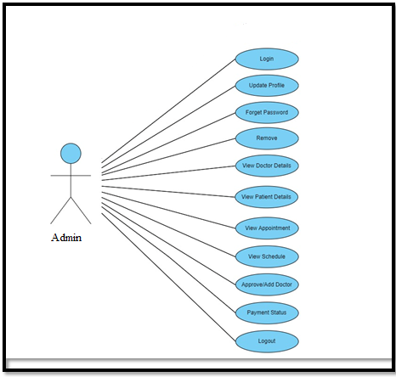

***Fig. Use case diagram for Admin***

1. In Admin use case diagram Admin is the Actor.
2. Admin can handle following use cases:
3. Login
4. Update Profile
5. Forget Password
6. Remove
7. View Doctor Details
8. View Patient Details
9. View Appointment
10. View Schedule
11. Approve/Add Doctor
12. Payment Status
13. Logout

**Doctor:**

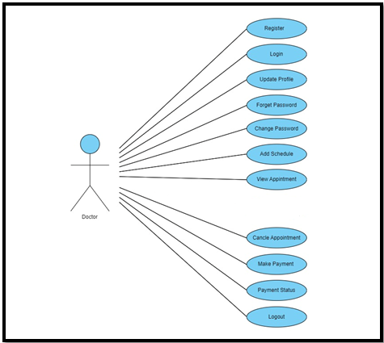

***Fig. Use case diagram for doctor***

1. In Doctor use case diagram Doctor is the Actor.
2. Doctor can handle following use cases:
3. Register
4. Login
5. Update Profile
6. Forget Password
7. Change Password
8. Add Schedule
9. View Appointments
10. Update Schedule
11. Cancel Appointment
12. Make Payment
13. Payment Status
14. Logout

**Patient:**

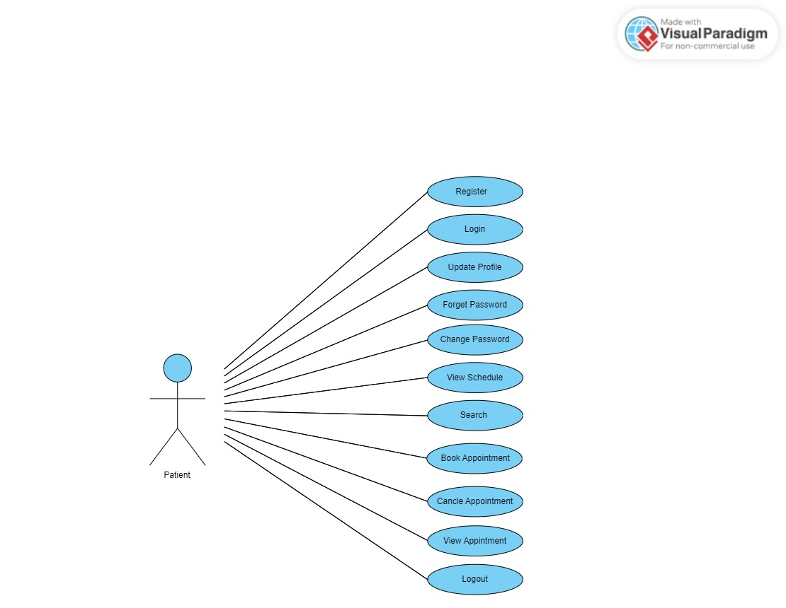***Fig. Use case diagram for patient***

1. In Patient use case diagram Patient is the Actor**.**
2. Patient can handle following use cases:
3. Register
4. Login
5. Update Profile
6. Forget Password
7. View Schedule
8. Search Doctor
9. Book An Appointment
10. Cancel Appointment
11. View Appointment
12. Logout

#### 2.5 ER- Diagram

